|  |
| --- |
| Multicore Computing Project1 |

- Problem 1 -



|  |  |
| --- | --- |
| 과목명 | 멀티코어컴퓨팅 |
| 제출일 | 2023.04.15. |
| 학 번 | 20183901 |
| 학 과 | 소프트웨어학부 |
| 이 름 | 김상민 |

|  |
| --- |
| 목 차 |

1. Problem-1

• Environment

• Result

• Explanation/Analysis

• Source code

|  |
| --- |
|  |

**1. Problem-1: Prime number count**

**(a). Environment**

Model: MacBook Air(M1, 2020)

Chip: Apple M1

Cores: 4+4 (P: 4 / E: 4)

RAM: 16 GB

**(b). Result**

|  |  |  |  |  |  |  |  |  |  |  |
| --- | --- | --- | --- | --- | --- | --- | --- | --- | --- | --- |
| **exec time(ms)** | **1** | **2** | **4** | **6** | **8** | **10** | **12** | **14** | **16** | **32** |
| **static(block)** | 1090 | 818 | 493 | 416 | 382 | 363 | 354 | 328 | 315 | 313 |
| **static(cyclic)** [task size: 10] | 1088 | 570 | 377 | 406 | 313 | 324 | 312 | 335 | 313 | 303 |
| **dynamic** [task size: 10] | 1090 | 568 | 344 | 324 | 330 | 311 | 304 | 334 | 303 | 298 |

|  |  |  |  |  |  |  |  |  |  |  |
| --- | --- | --- | --- | --- | --- | --- | --- | --- | --- | --- |
| **performance (1/exec time)** | **1** | **2** | **4** | **6** | **8** | **10** | **12** | **14** | **16** | **32** |
| **static(block)** | 0.92 | 1.22 | 2.03 | 2.40 | 2.62 | 2.75 | 2.82 | 3.05 | 3.17 | 3.19 |
| **static(cyclic)** [task size: 10] | 0.92 | 1.75 | 2.65 | 2.46 | 3.19 | 3.09 | 3.21 | 2.99 | 3.19 | 3.30 |
| **dynamic** [task size: 10] | 0.92 | 1.76 | 2.91 | 3.09 | 3.03 | 3.22 | 3.29 | 2.99 | 3.30 | 3.36 |

**(c). Explanation/Analysis**

If we look at the result, overall execution time showed decreasing trend and performance showed the opposite.

Among three types, Static block load balancing had the longest execution time. It is because if we do load balancing in large blocks, there will be less chance for threads to have equal workloads. In the program, we start all threads at once but must wait for all threads to end since the program returns the sum of all threads’ count.

On the other hand, Static cyclic method had shorter execution time than static block method. This is because when using cyclic method, workloads are more likely to be distributed and the program to have better load balancing.

Dynamic load balancing showed the best performance and minimum execution time. When one thread finishes allocated work, it takes work from a work queue. By this way, works can be distributed efficiently, so dynamic load balancing is ideal for codes where work is uneven.

**(d). Source code**

**• Static block code**

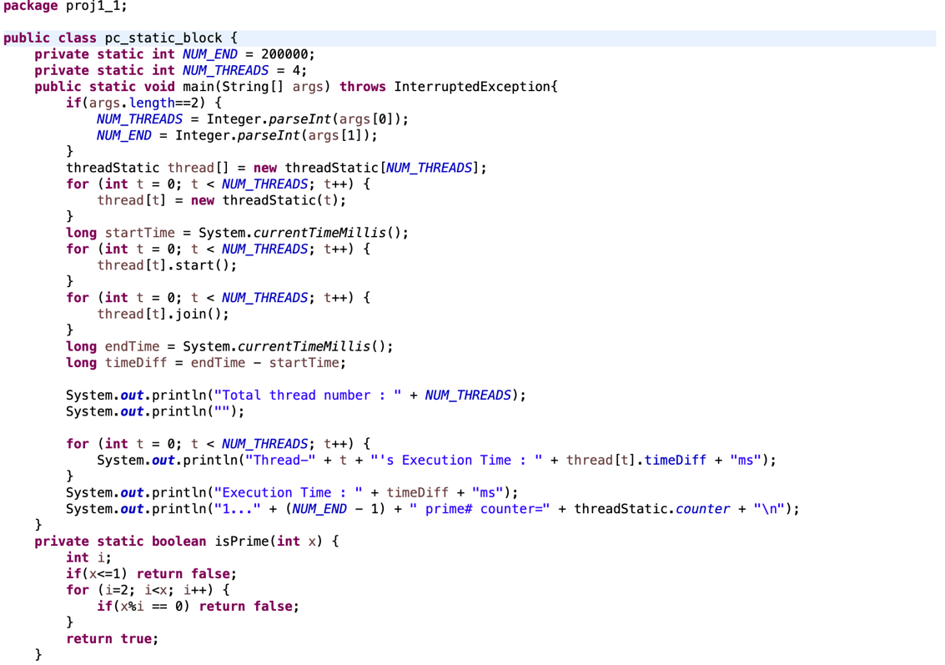

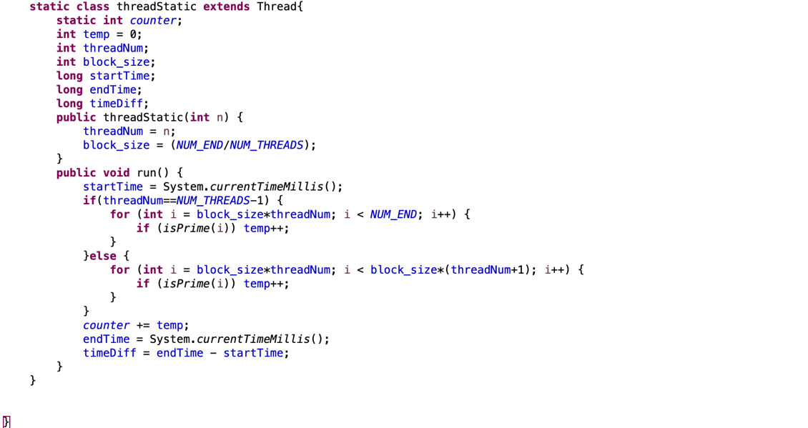

**• Static block output**

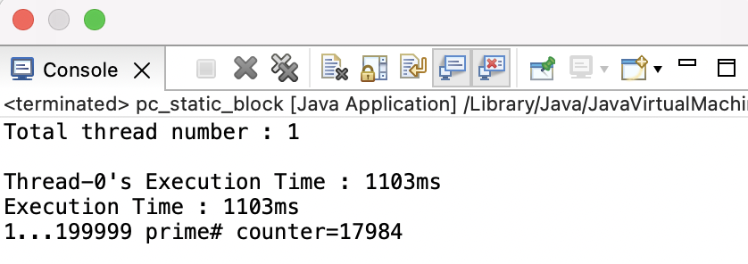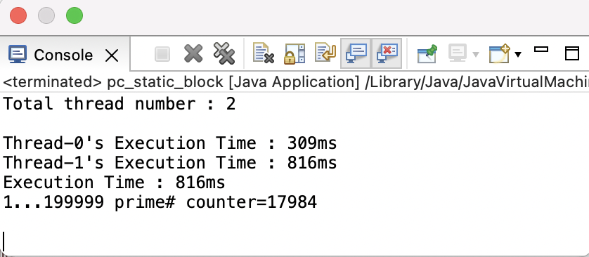

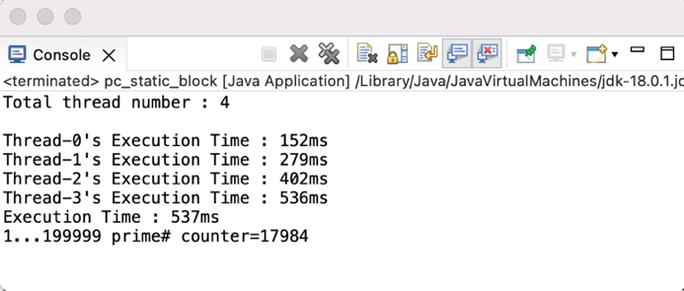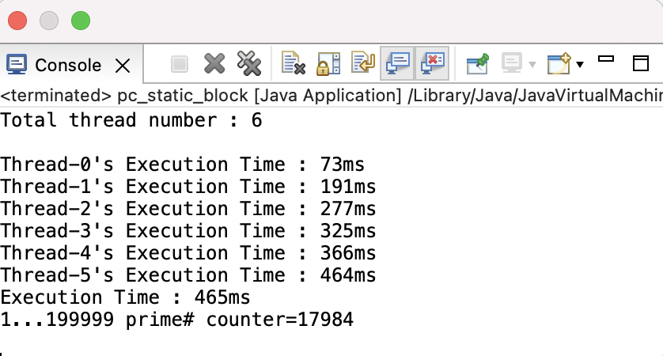

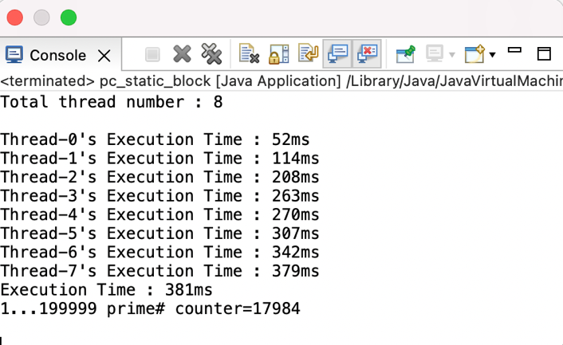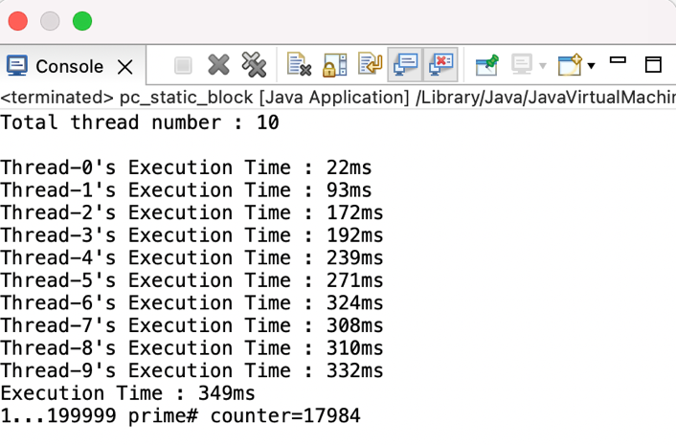

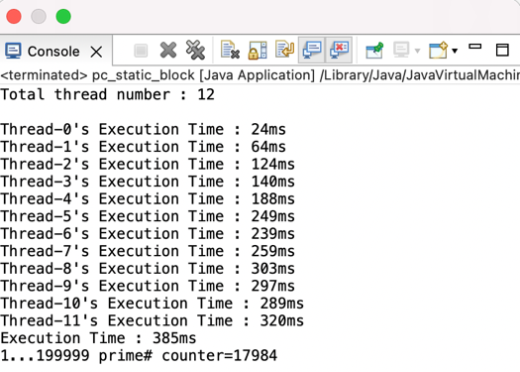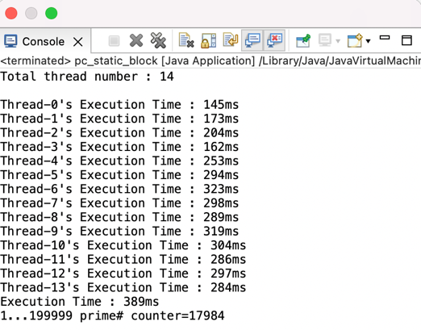

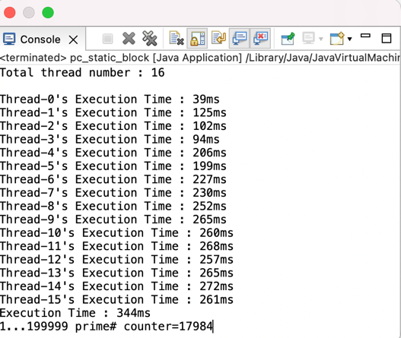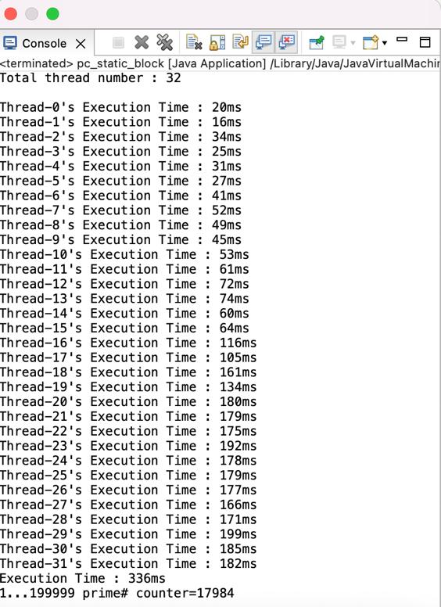

**• Static cyclic code**

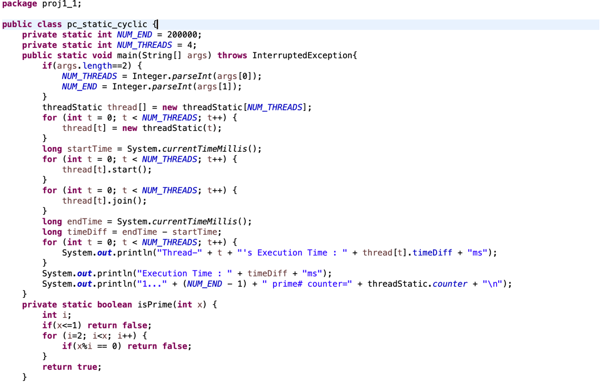

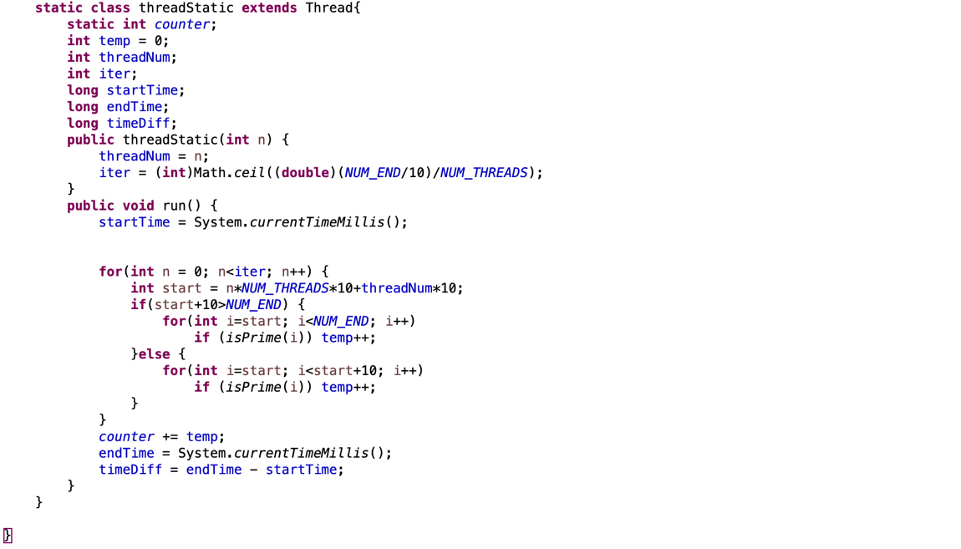

**• Static cyclic output**

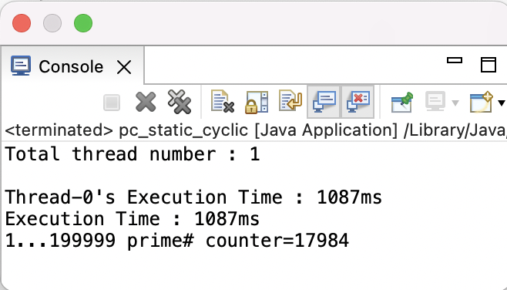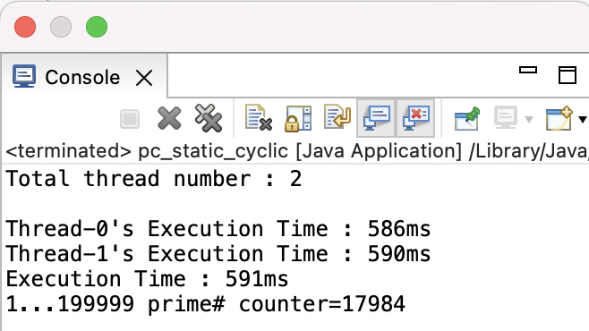

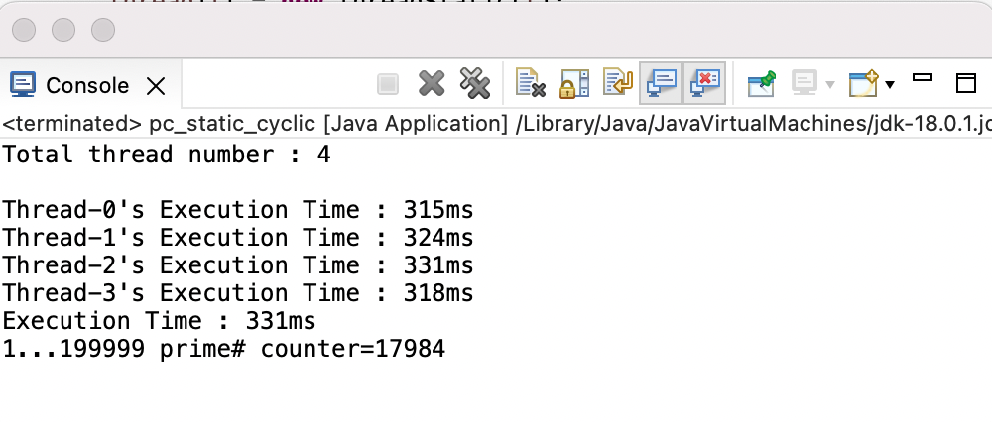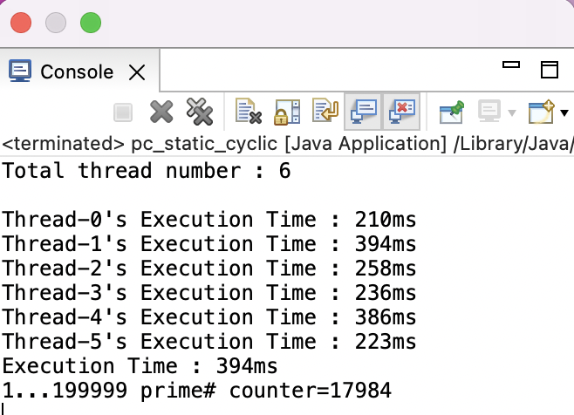

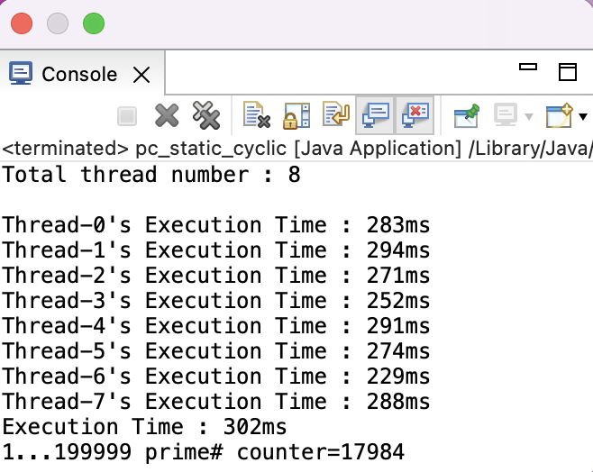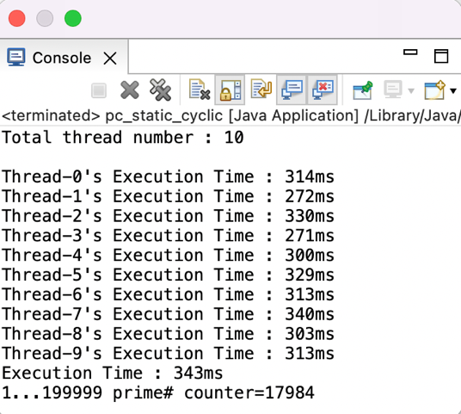

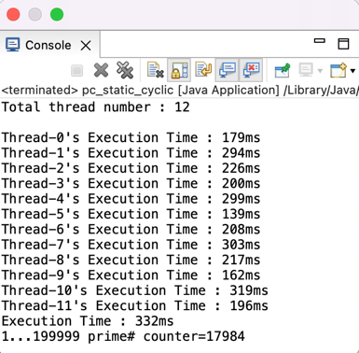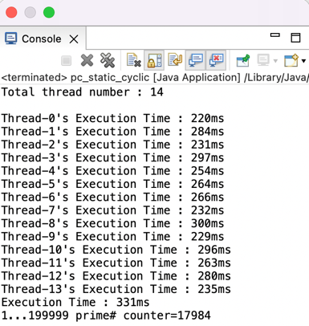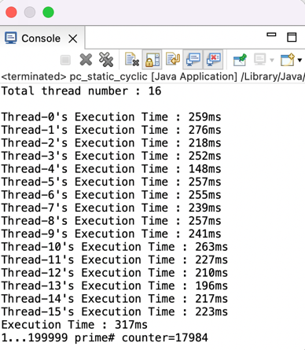

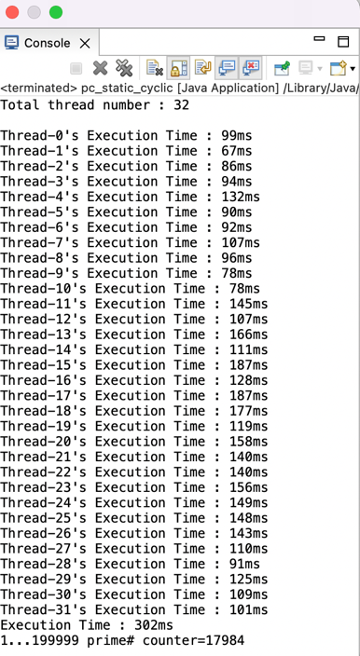

**• Dynamic code**

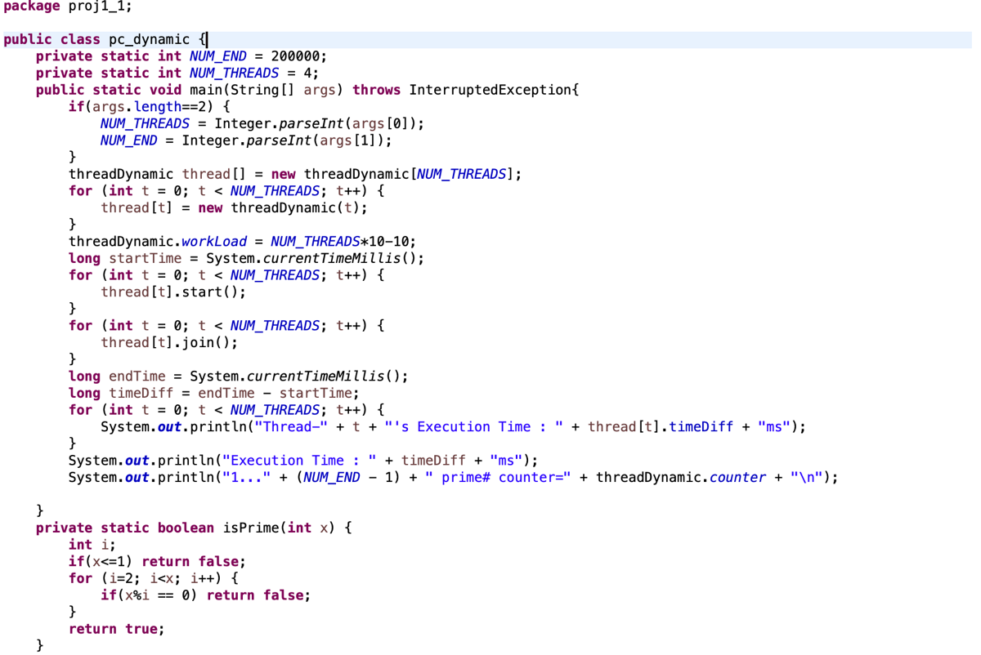

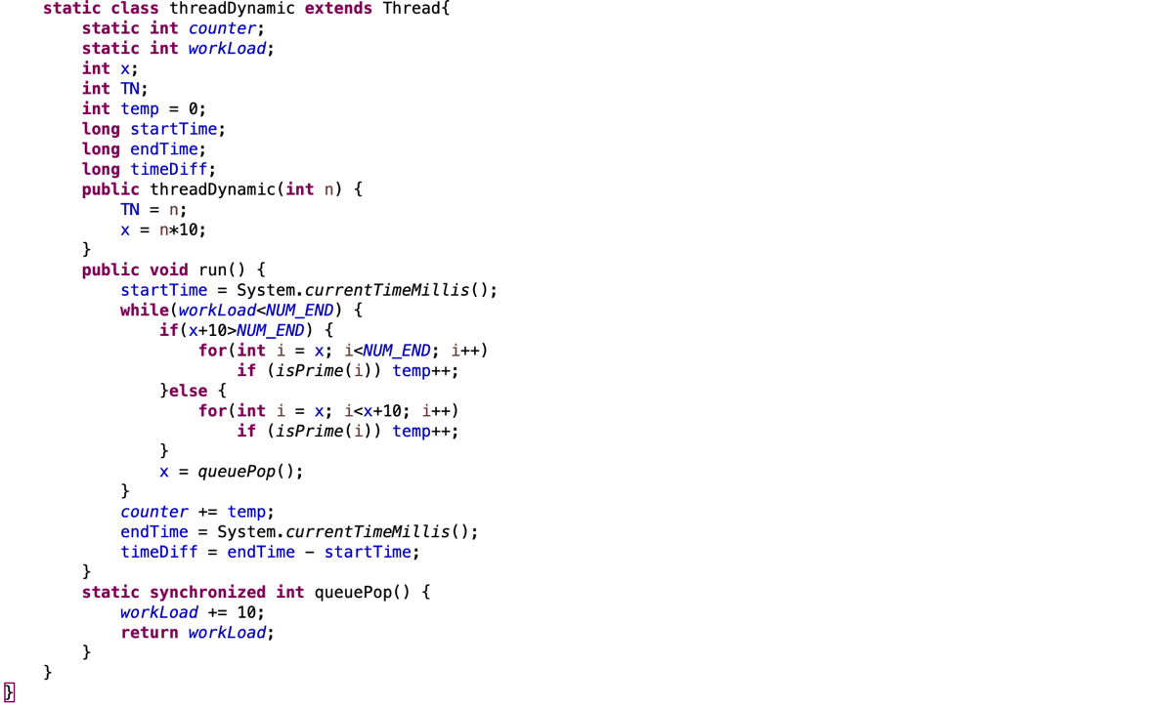

**• Dynamic output**

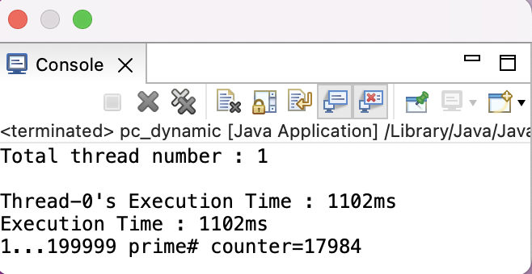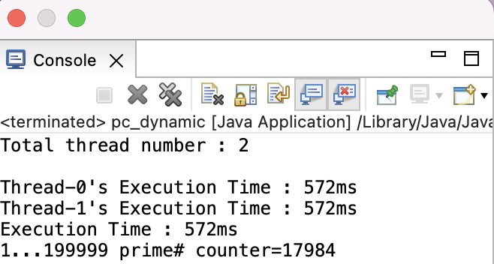

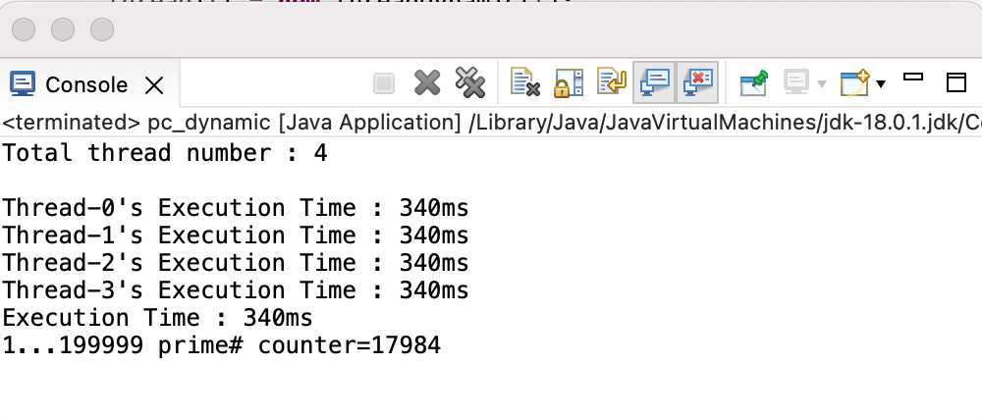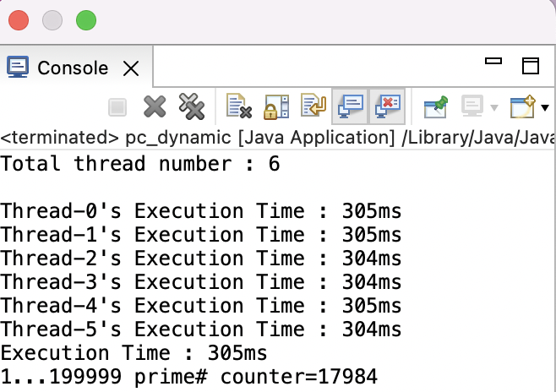

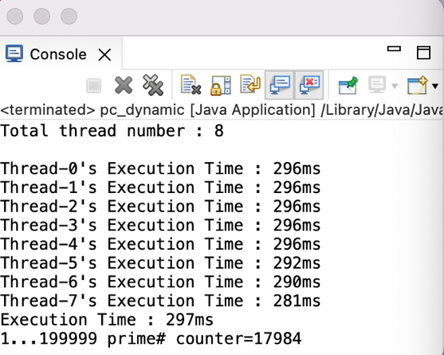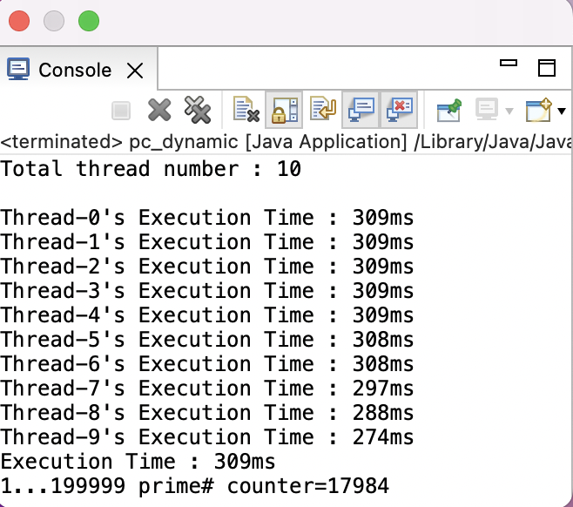

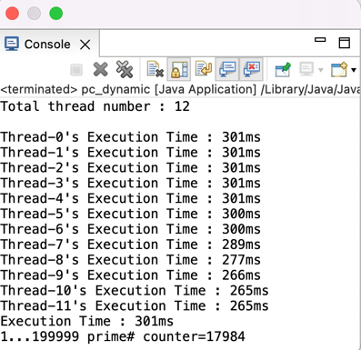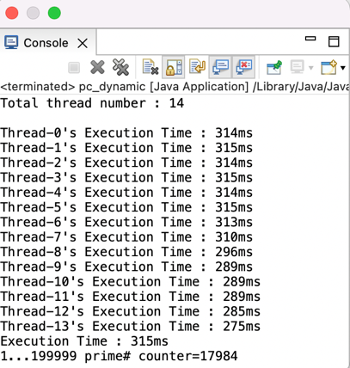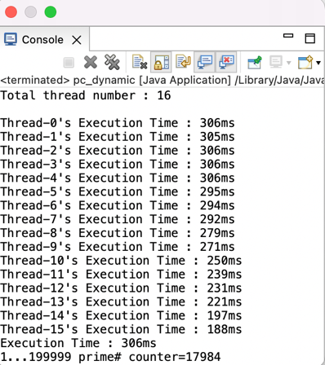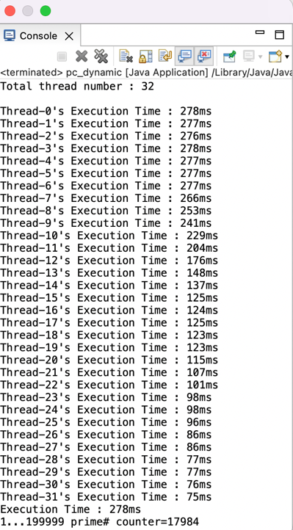

**• How to run**

Set default ‘NUM_END’ to set maximum number you are checking.

Set default ‘NUM_THREADS’ to set total numbers of threads you will make.